**2024.08.06**

**Engineering Question of PN:OCXO_DaughterCard**

**Question 1:**  See below IMG, there are some doubt about the via holes, please confirm

**Suggestion 1:** All via holes are plugged with epoxy resin and capped(Include there are soldmask opening on both sides of via holes-See arrow marked)

**Suggestion 2:** Just plugged epoxy resin with no soldmask opening of via holes. No need plugged with epoxy resin which there are soldmask opening on both sides of via holes.

**Reply: Suggestion 2**

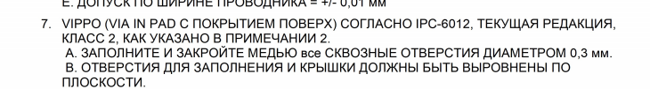

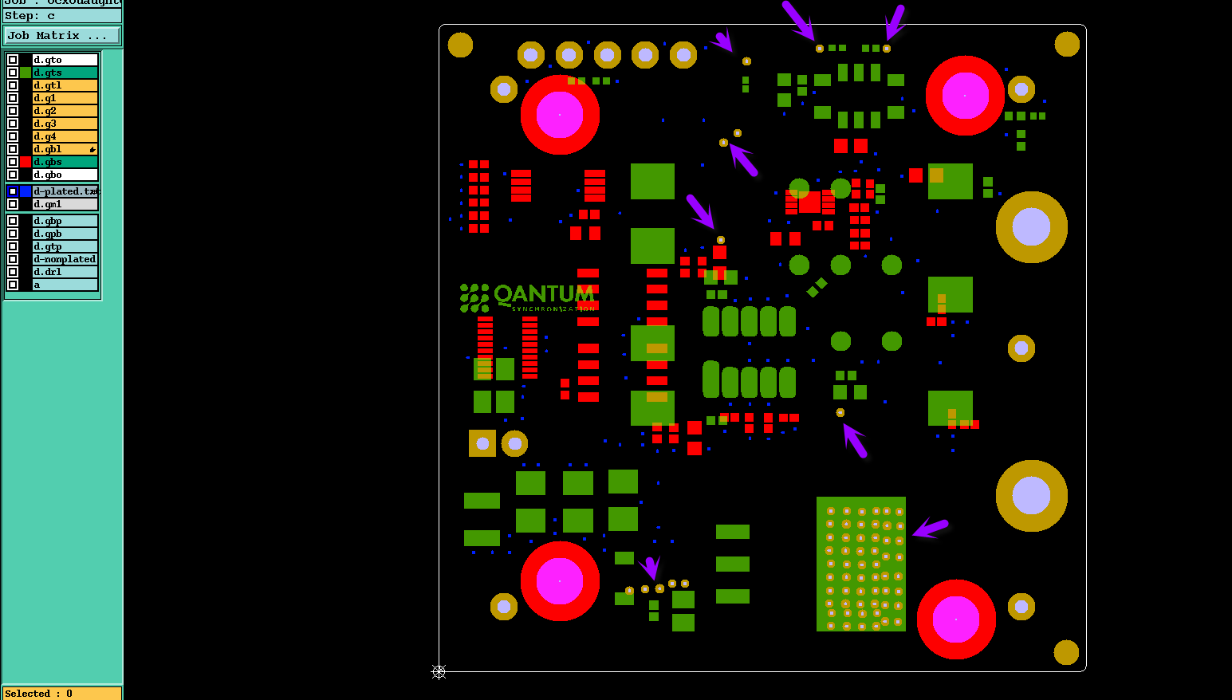

**Question 2:** See below IMG,the tolerance of Cu traces too tight to control

**Suggestion:** Relax to +/-20%.

**Reply: YES**

**PIC2:**

